**ITI – AIPRO Track**



Machine Learning Intern.

Job title Classification by industry

(Multi-text Text Classification Task)

**By / Mohammed AL-Sayed Agoor**

**LinkedIn:** [MOHAMMED AGOOR | LinkedIn](https://www.linkedin.com/in/civilianoagoor/)

**GitHub:** [AGOOR97 (Mohammed Agoor) (github.com)](https://github.com/AGOOR97)

**E-mail:** [mohammedagoor1997@gmail.com](mailto:mohammedagoor1997@gmail.com)

**Youtube:** [Mohammed Agoor - YouTube](https://www.youtube.com/c/MohammedAgoor/videos)

* **Attached Files and Links:**
* **My Video on General Steps to run API**

[General Steps of my Project - YouTube](https://www.youtube.com/watch?v=KsU01Kfpejg)

* **Files:**

01**_Code:**

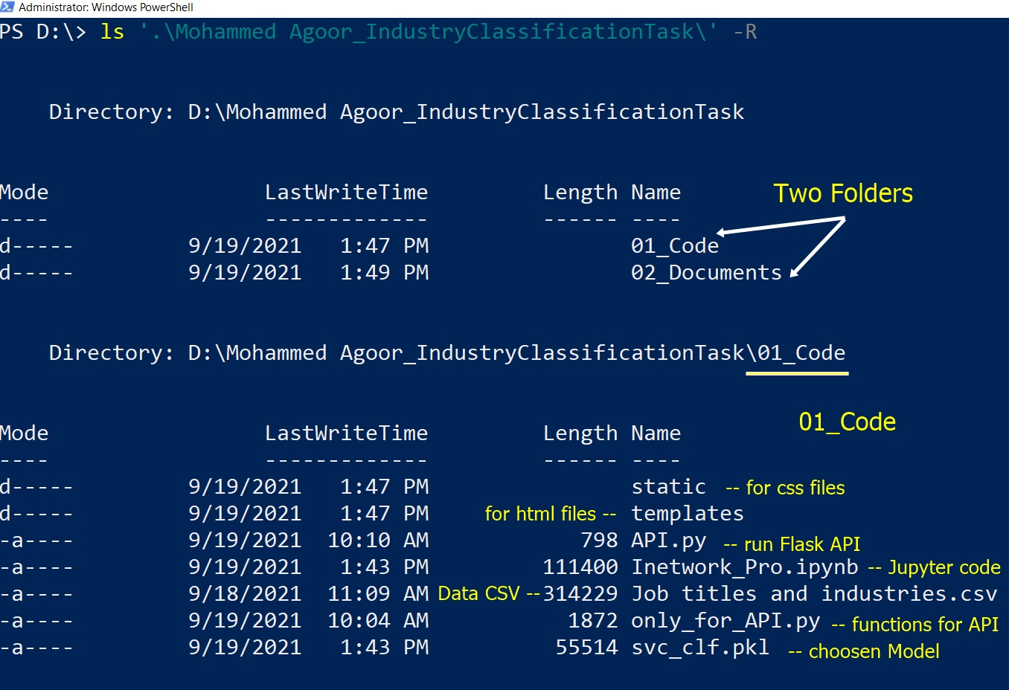

02**_Docuemnt:**

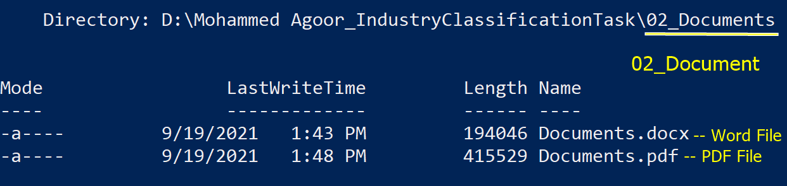

**1.1 Project Description:**

**You can think of the job industry as the category or general field in which**

**you work. On a job application, "industry" refers to a broad category under**

**which a number of job titles can fall. For example, sales is an industry; job**

**titles under this category can include sales associate, sales manager,**

**manufacturing sales rep, pharmaceutical sales and so on.**

**1.1.a Project Dataset:**

[Job titles and industries.csv - Google Drive](https://drive.google.com/file/d/1W_MO19MlDDUn0qCfxEaVxGKKlKHsFFly/view)

**1.1.b Project Details:**

**You are given a dataset that has two variables (Job title & Industry) in a csv**

**format of more than 8,500 samples.**

**This dataset is imbalanced (Imbalance means that the number of data**

**points available for different classes is different) as follows:**

**IT 4746**

**Marketing 2031**

**Education 1435**

**Accountancy 374**

**----------------------------------------------------------------**

**1.2 Steps of My Code:**

**Check attached Jupyter NoteBook named (‘Inetwork_Pro.ipynb’)**

* **Import the required Libraries and Algorithms**
* **Loading the Data (attached CSV file)**
* **Looking at the Big Picture of this Data and try to make insights**
* **Check for Null Data (no nulls), decide to drop duplicates or not**
* **Before Preprocessing, split the Data to train & val and test sets**
* **EDA and some Preprocessing Steps including Vectorization**
* **Now we are ready to train Models**
* **But because of imbalanced Weights of each Class, I will give more weight to these class which are underrepresented (more details .. later)**
* **Starting by Naïve then Logistic then RandomForest then LinearSVC and ending with Xgboost Algorithms**
* **Try to Tuning the best One which is the LinearSVC**
* **Note; I choose LinearSVC not svm.SVC Classes (more details .. later)**
* **Ending of Tuning of LinearSVC and download this Model (.pckl)**
* **Evaluation on Test Set and Check out Accuracy (my choose Metric)**
* **Finally, I end with some Resources**

**1.3 Answer the Questions:**

1. **Which techniques you have used while cleaning the data if you have**

**cleaned it?**

* **I found no nulls in the Data, I think it is clear, but have much duplicates, so I decided to not drop these duplicates in this step and try to predict and get Accuracy if it is bad come back and remove duplicates, but in this step, I do not remove duplicates and the Accuracy is not bad.**

**But if I have much time I will come back, dropping duplicates and check what my Accuracy is.**

**--------------------------------------------------------**

1. **Why have you chosen this classifier?**

**I choose (LinearSVC)**

1. **The Highest Accuracy of these tried Algorithms**
2. **LinearSVC does not have much parameter to tune (I think only C need to be tuned), I mean LinearSVC not svm.SVC**
3. **LinearSVC is much faster than svm.SVC**

* **If I have much time I will do more Tuning using (skopt or Hpsklearn or RandomizedSearchCV)**
* **And try other Algorithms such as (SGDClassifier, VotingClassifier, other kernels of SVM).**

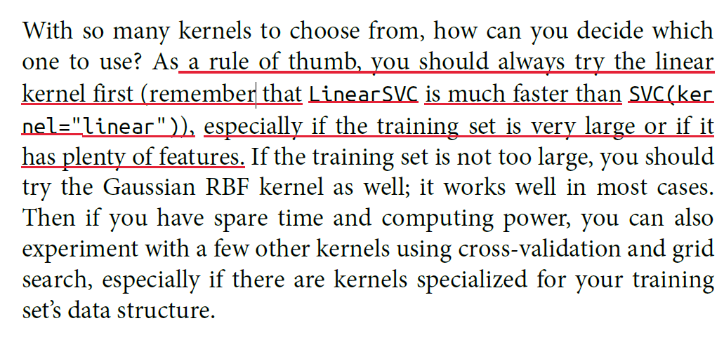

**Hands-on-ML**

1. **How do you deal with (Imbalance learning)?**

* **I give more Weights to the underrepresented Classes and give less wights to the overrepresented Classes**
* 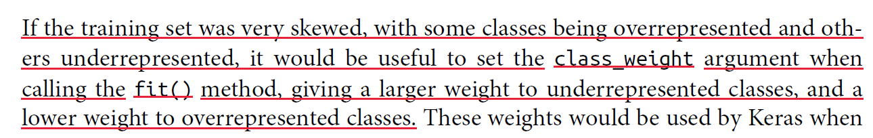**I calculated these weights (check my Jupyter Notebook) by getting the Probability of each Class (we will reverse) these Probability so I subtract it from 1. And give these class_weights to the Algorithms as HyperParameter.**

**Hands-on-ML**

**--------------------------------------------------------**

1. **How can you extend the model to have better performance?**

* **I can extend the Model Performance as I said previously by try Tuning its HyperParameter using advanced techniques such as (Hpsklearn or Hyper-opt libraries using BayesianSearcCV)**
* **I can try more Algorithms such as (SGDClassifier, try other kernels in svm, VotingClassifier, using Ensemble Learning(ADaboost or Bagging or Pasting techniques))**
* **All these Steps need Time and Resources**

**--------------------------------------------------------**

1. **How do you evaluate your model? (i.e. accuracy, F1 score, Recall)?**

* **I evaluate my Model using (Accuracy)**
* **I choose Accuracy, because it make sense here in multiclass**
* **Precision and Recall or even F1_score, I do not think none of them make sense to be the metric here although we have biased data, but they make sense much more in Binary Classification.**

1. **What are the limitations of your methodology or Where does your**

**approach fail?**

* **After running this ,**

**(pd.DataFrame(np.c_[y_test, y_pred_test], columns=['actual', 'predicted']))**

* **In my Opinion:**

**I found that IT may be misclassified with other Categories, I mean that IT is a side of error, the common is that every misclassified instance is containing IT whether it is actual or predicted, we can reduce error by giving a little bit more weight to class IT.**

**--------------------------------------------------------**

**2. Resources:**

**Books**

**1. Hands-on-ML (by Aurilien Geron)**

**2. Deep Learning with Python (by Francois Chollet 'Author of Keras')**

**Links**

* **vectorize Troubleshoot**

[scikit learn - Python Sklearn TfidfVectorizer Feature not matching; delete? - Data Science Stack Exchange](https://datascience.stackexchange.com/questions/30620/python-sklearn-tfidfvectorizer-feature-not-matching-delete)

**Flask API**

* [krishnaik06/Deployment-flask (github.com)](https://github.com/krishnaik06/Deployment-flask)
* [Deploy Machine Learning Model Flask - YouTube](https://www.youtube.com/watch?v=MxJnR1DMmsY)
* [Deploy Machine Learning Model using Flask - YouTube](https://www.youtube.com/watch?v=UbCWoMf80PY)

**--------------------------------------------------------**